
Ansible:
Ansible is an open-source IT engine that automates application deployment, cloud provisioning, intra-service orchestration, and other IT tools. It is an automation and orchestration tool popular for the following reasons:
- Simple to Install.
- Free and open source.
- Lightweight and consistent.
- OpenSSH security features make it very secure.

Ansible Architecture
- Control node: Commands and Playbooks can run by invoking /usr/bin/ansible or /usr/bin/ansible-playbook, from any control node. You can use any computer that has Python installed on it as a control node. However, one can not use a computer with Windows OS as a control node. One can have multiple control nodes.
- Managed nodes: Also sometimes called "hosts", Managed nodes are the network devices (and/or servers) you manage with Ansible.
- Inventory: Also sometimes called "hostfile", Inventory is the list of Managed nodes use to organize them. It is also used for creating and nesting groups for easier scaling.
- Modules: These are the units of code executed by Ansible. Each module can be used for a specific purpose. One can invoke a single module with a task, or invoke several different modules in a playbook.
- Tasks: The units of action in Ansible. One can execute a single task once with an ad-hoc command.

- Setup one master and two worker nodes in ansible.
Prerequisites
Before running any playbooks, ensure your environment meets these requirements:
- Control Node: A machine with Ansible installed (version 2.9+ recommended) and SSH access to all nodes.
- Target Nodes: Three Linux instances (Ubuntu 22.04 or 24.04 preferred) with:
  - Master Node: Minimum 2 vCPUs and 2GB RAM.
  - Worker Nodes: Minimum 1 vCPU and 1GB RAM.
- Networking: All nodes must have static IP addresses and be able to communicate with each other.
- User Access: A user with passwordless sudo privileges on all target nodes.
- SSH Keys: Your Control Node's public key must be in the ~/.ssh/authorized_keys file of every node.
Launching the instances using terraform
Syntax:
resource "aws_instance" "ansible" {
ami = "ami-0b6c6ebed2801a5cb"
instance_type = "t3.micro"
count = 3
tags = {
Name = ["ansible-Controller", "Worker-2", "wORKER-3"][count.index]
}
}

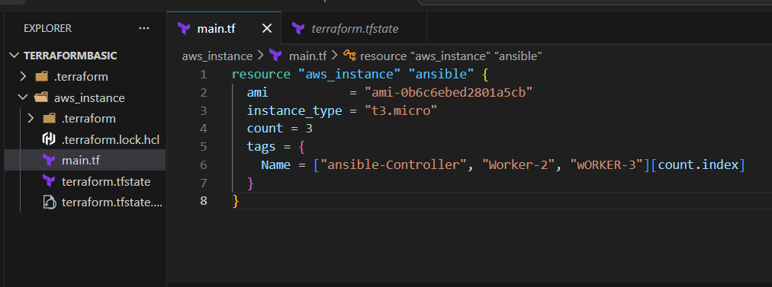
Launched 3 instances and named them for identification
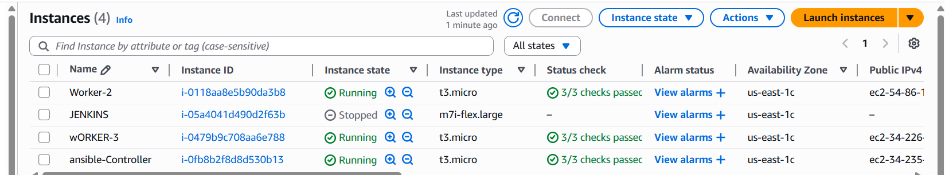
Connect to control or master server
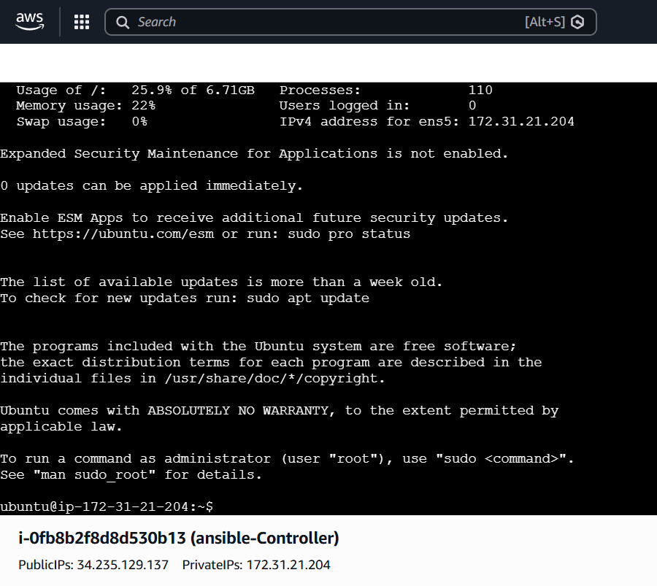

Update the packages and verify the python version and update the packages
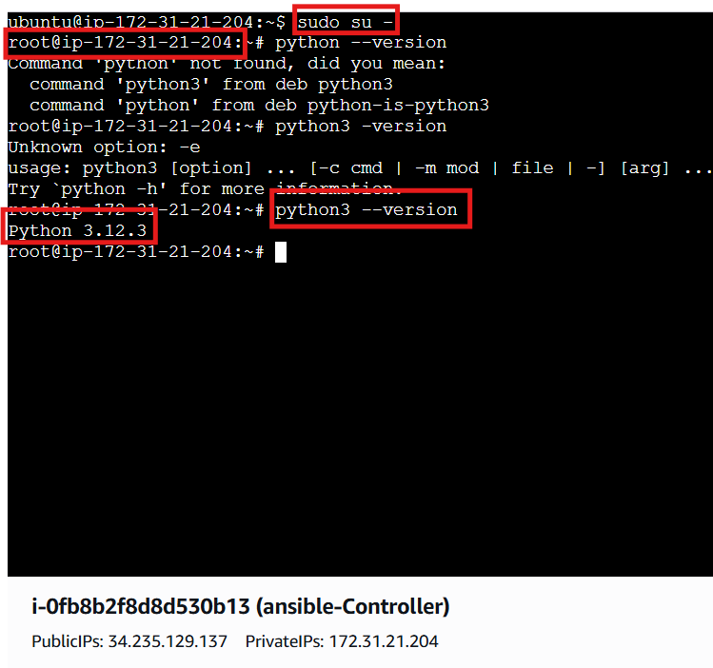
Also update the packages
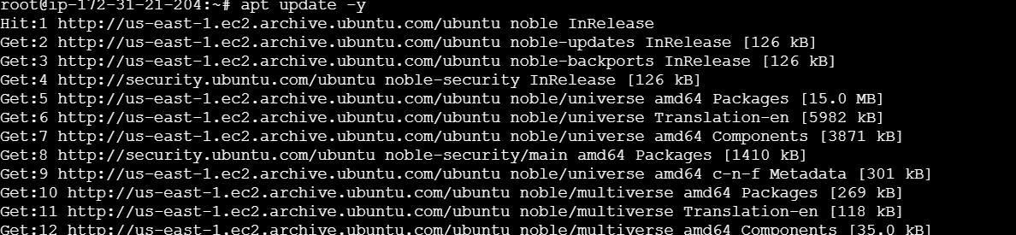

Install ansible on master or controller serverS
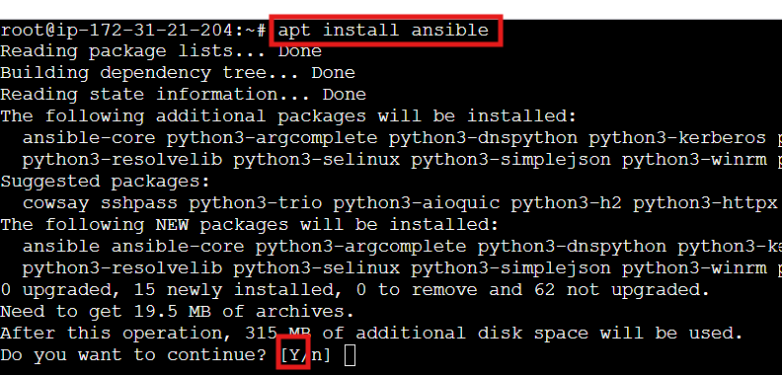
After installation check the version and congig file location

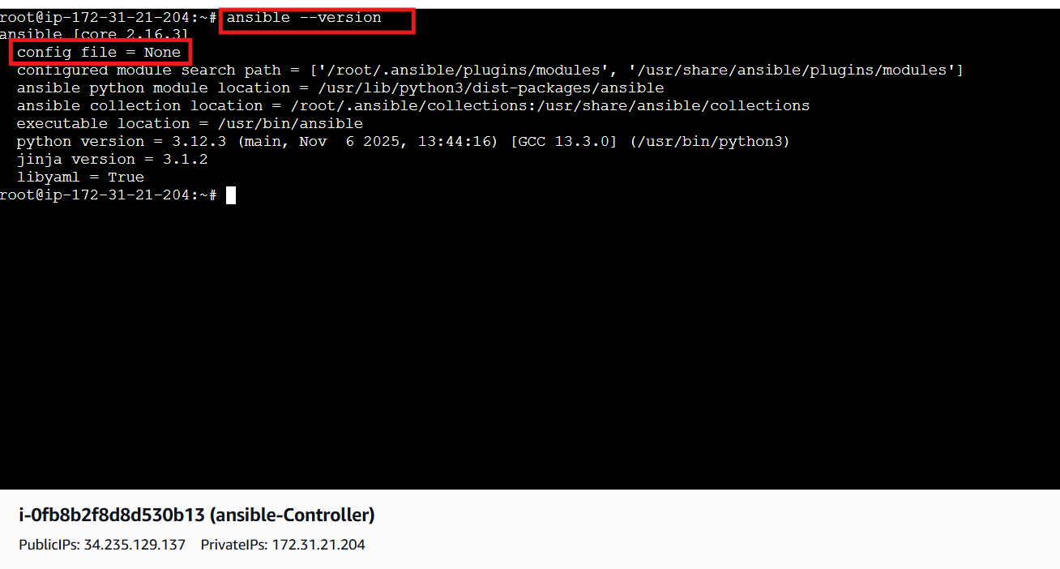

Create a directory /etc/ansible and create a file .cfg and add the data into it and verify the version again
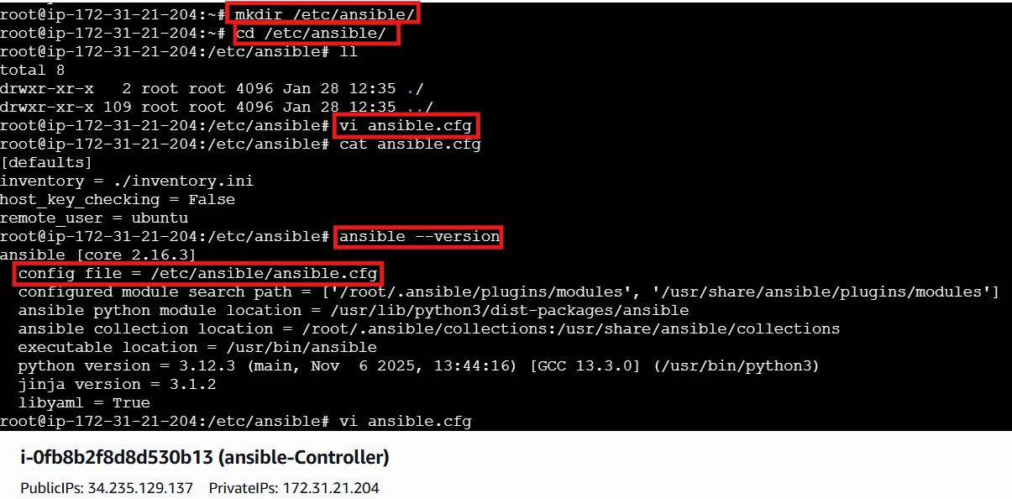
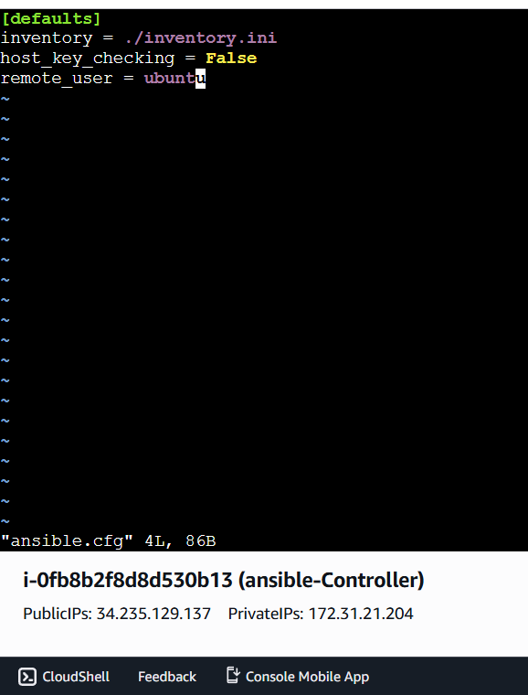

Create a file named hosts inside of ansible /etc/ansible/hosts and add the data
The data is the private ip address of worker machines and add column of [all]
And [groups]
[all] means the execution happens on all worker machines
[groups] means the execution happens on specified machines inside of the group
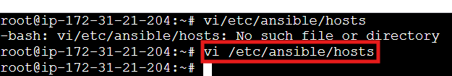
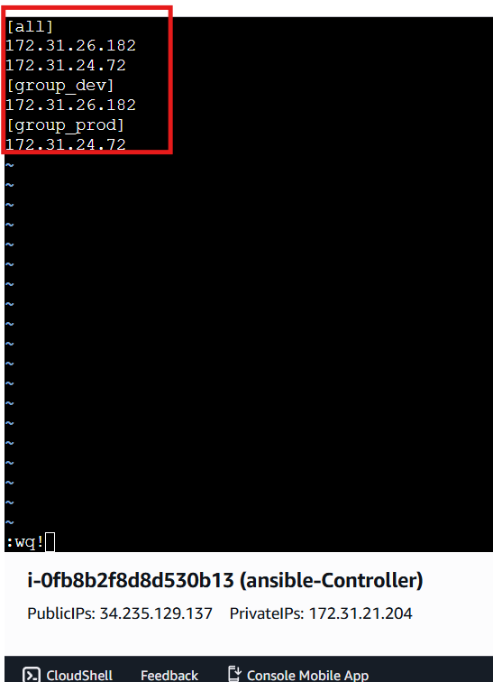

Executed the command ping and got an error to resolve it open congig file and remove inventory line and execute again
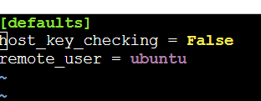
After that execute again
Got the error of permission error so that we need to establish a secure connection using SSH
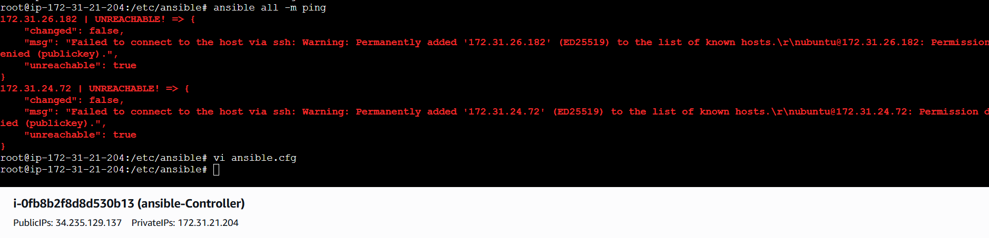
Generate SSH-keygen on controller and copy the public key and paste in worker machines .ssh/authorize_keys file
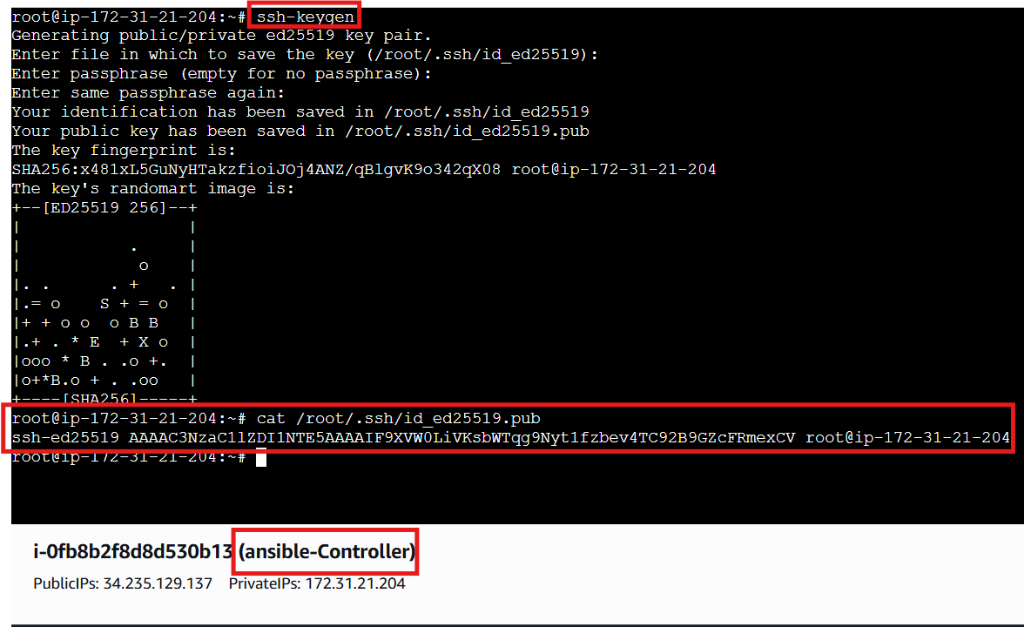
On the worker machine add the public key in authorize keys which copied ffrom master machine and execute ping command from main machine
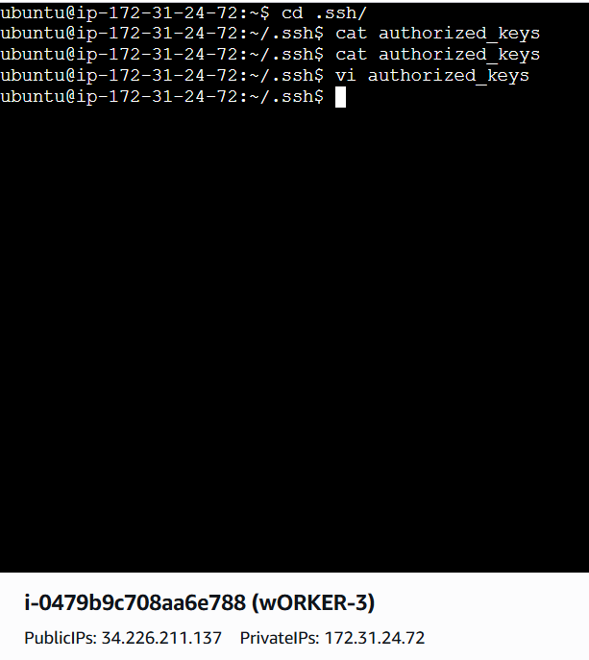
One server is get connected and another is not because on only one machine we configure the ssh so that only one machine is connected
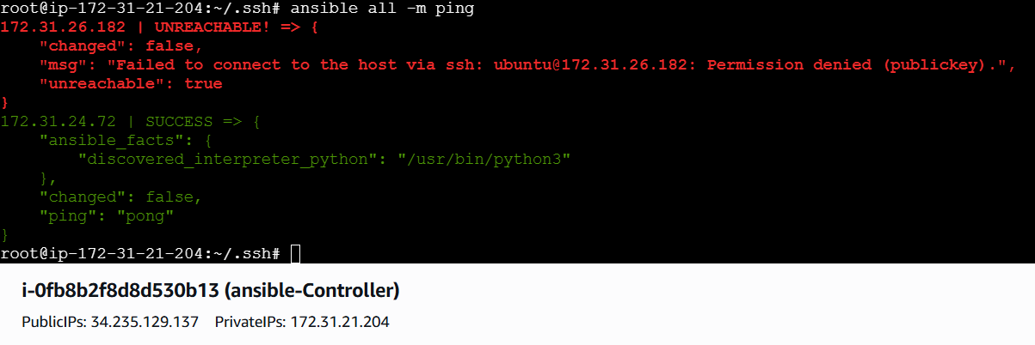

Do the same for other worker machine
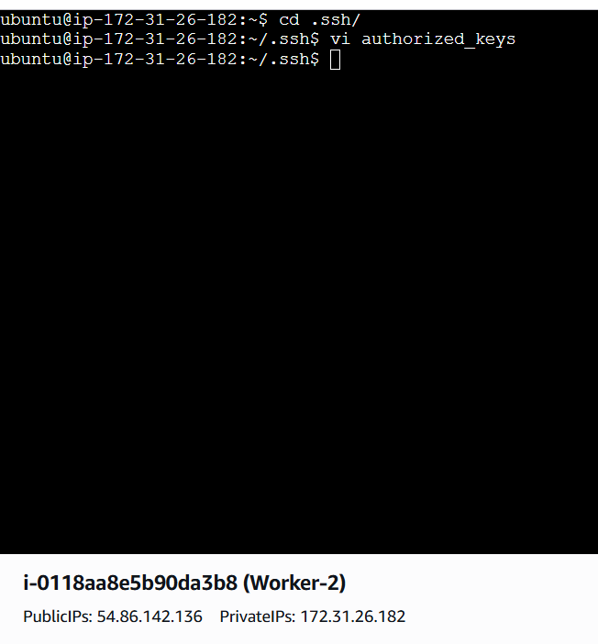
After that executed the commands and connected successfully
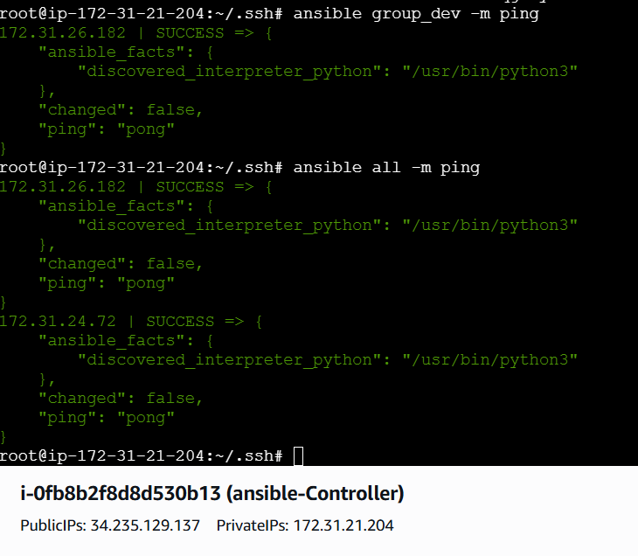
Execute the adhoc command shared::
# To check the connetivity between slaves
ansible all -m ping
ansible all -m ping -i ansible_hosts

# How to gather facts of slave machine
ansible all -m setup

# Tips: -i is used if we are using more than one invertory file

# What if you do not have SSH key-based? How to pass username and password?
ansible all -m ping --user=ansadm --ask-pass

# TO checkthe uptime of a slave machine
ansible all -a uptime

# Tips: -m is the module and -a should contain the command it should run which goes as an argument to command and shell.

# check the free memory or memory usage of host
ansible all -a "free -m"

# Execute a command as root user (sudo) on host
ansible all -m shell -a "cat /etc/passwd|grep -i ansadm" -s --ask-sudo-pass

# Execute a command using become module
ansible all -m shell -a "cat /etc/passwd|grep -i ansadm" -b -K

# Tips: -b is the option for become and by default it will become root user
–K is to tell ansible to ask for SUDO password

#Execute a command as a different user (sudo su)
ansible all -m file -a "path=/home/ansadm/test state=directory mode=0755" -b --become-user=ansadm

# Create a Linux user group
ansible all -s -m group -a "name=test state=present" -b -K

# Create a file with 755 permission
ansible all -m file -a "path=/home/asnadm/testfile state=touch mode=0755"

# Change ownership of a file
ansible all -m file -a "path=/home/ansadm group=weblogic owner=weblogic" -b

# Install a package using yum command
ansible all -m yum -a "name=httpd state=installed"

# Start or stop the service
# To Start
ansible all -m service -a "name=httpd state=started enabled=yes"

# To Stop
ansible all -m service -a "name=httpd state=stop enabled=yes"

Execution
- ansible all -m ping {it ping all the worker nodes}
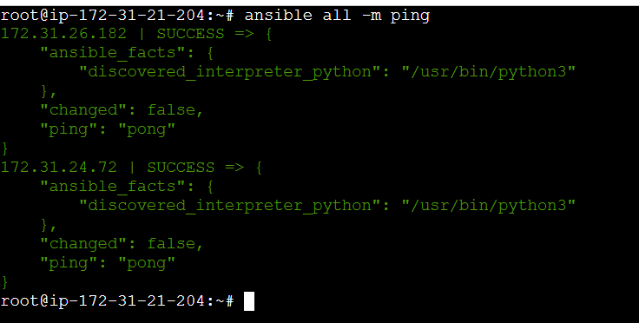
- ansible group_dev -m ping {only specified worker}
same if you have multiple groups
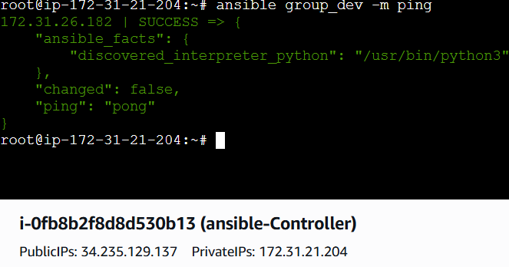
- ansible group_dev -m ping
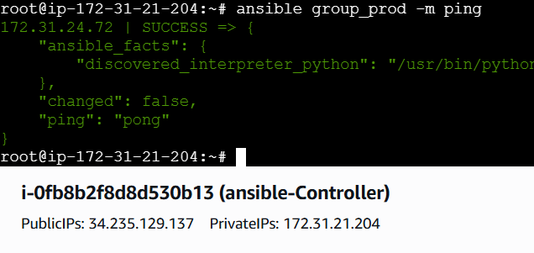
- ansible all -m setup {it gathers all the facts of worker machines}
- ansible group_dev -m setup {specified worker machine}
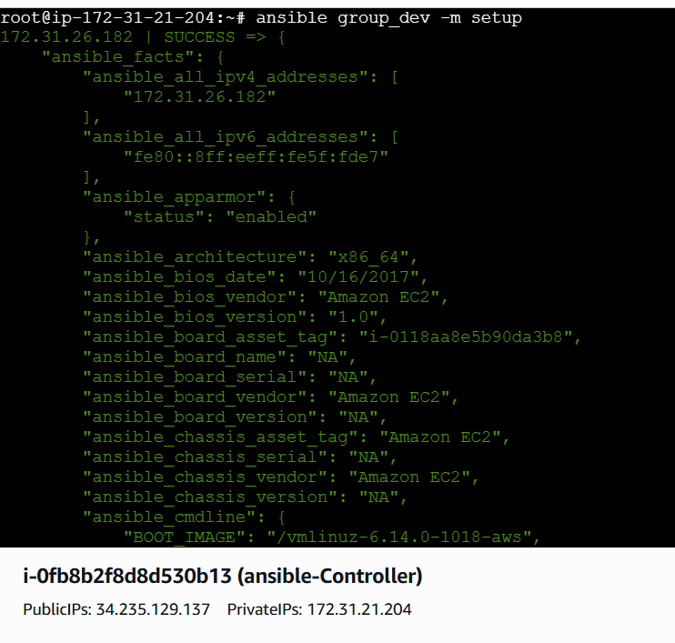

Check the uptime of servers using
- ansible all -a uptime
- ansible group_dev -a uptime
- ansible group_prod -a uptime
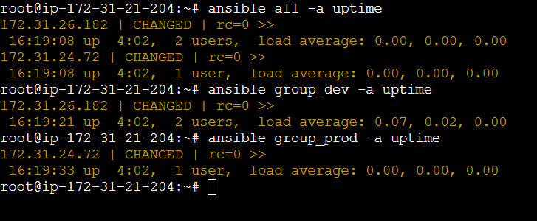
To check the free memory
- ansible all -a “free -m”
- ansible group_dev -a “free -m”
- ansible group_prod -a “free -m”
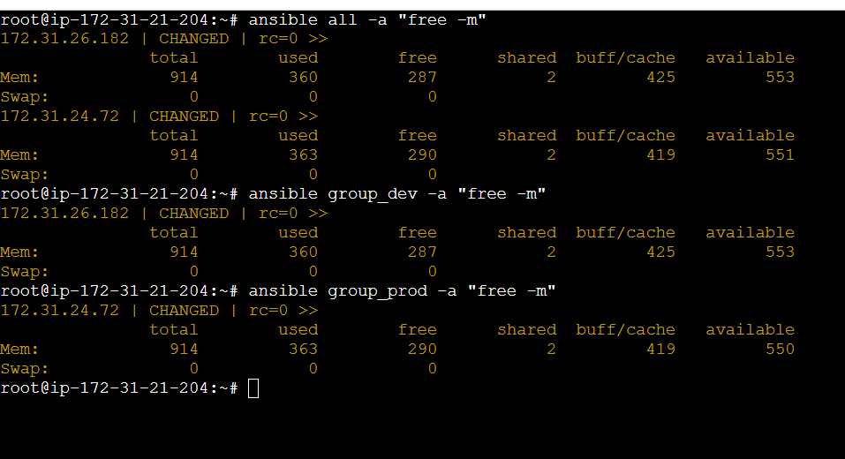

Create directory in worker machines
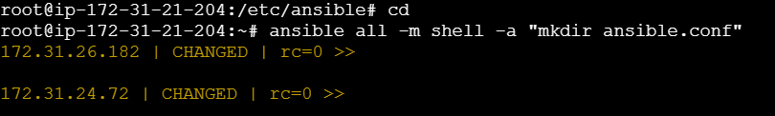
Verified in worker machines a dir has been created
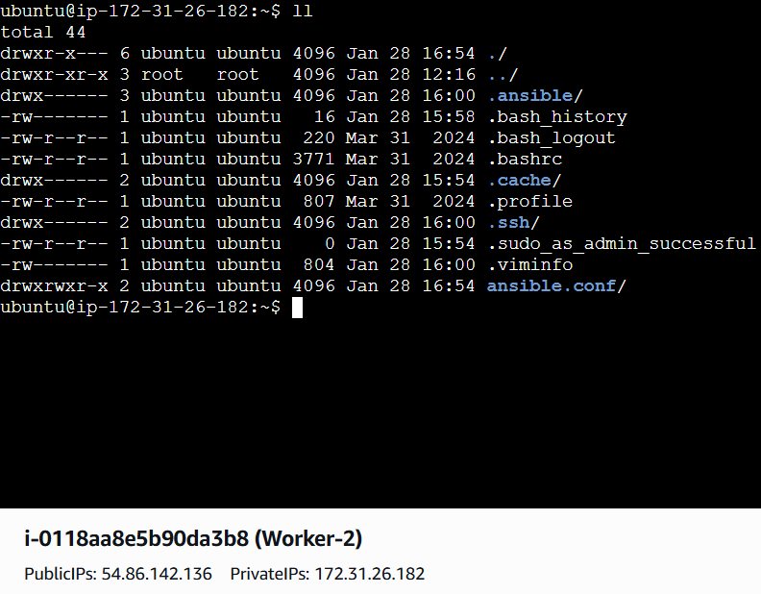

If you are getting any permission denied issues the execute the commands to update packages
ansible all -m apt -a "update_cache=yes cache_valid_time=3600" --become
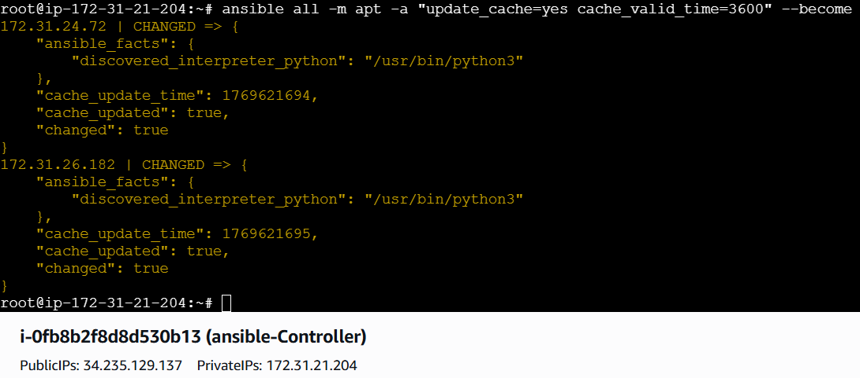
Command to install package
ansible all -m apt -a "name=apache2 state=latest" –become
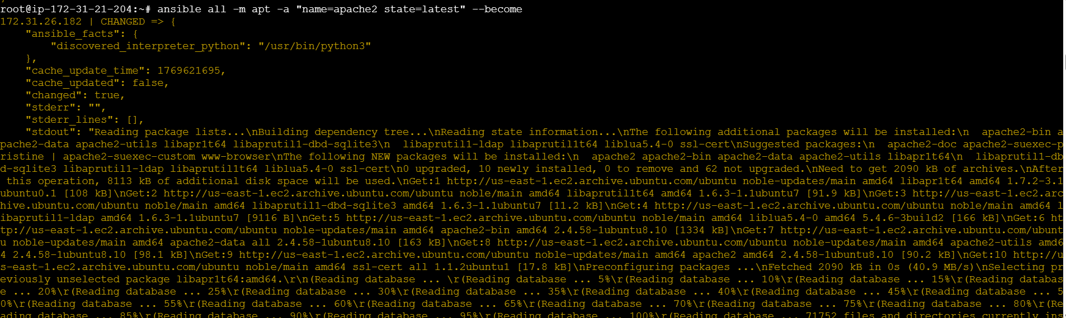

Command to start the service
ansible all -m service -a "name=apache2 state=started
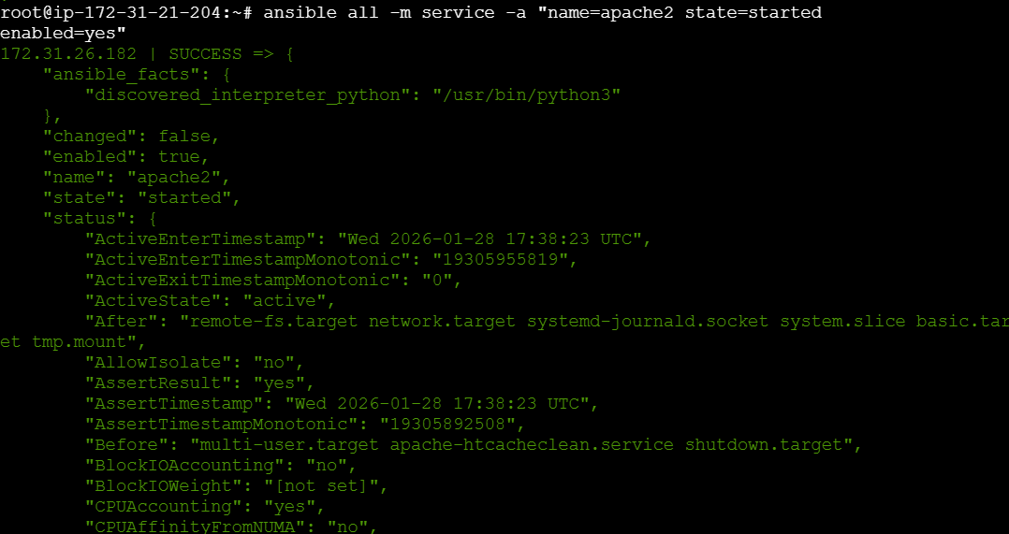
Validating on web
Using publicip@port
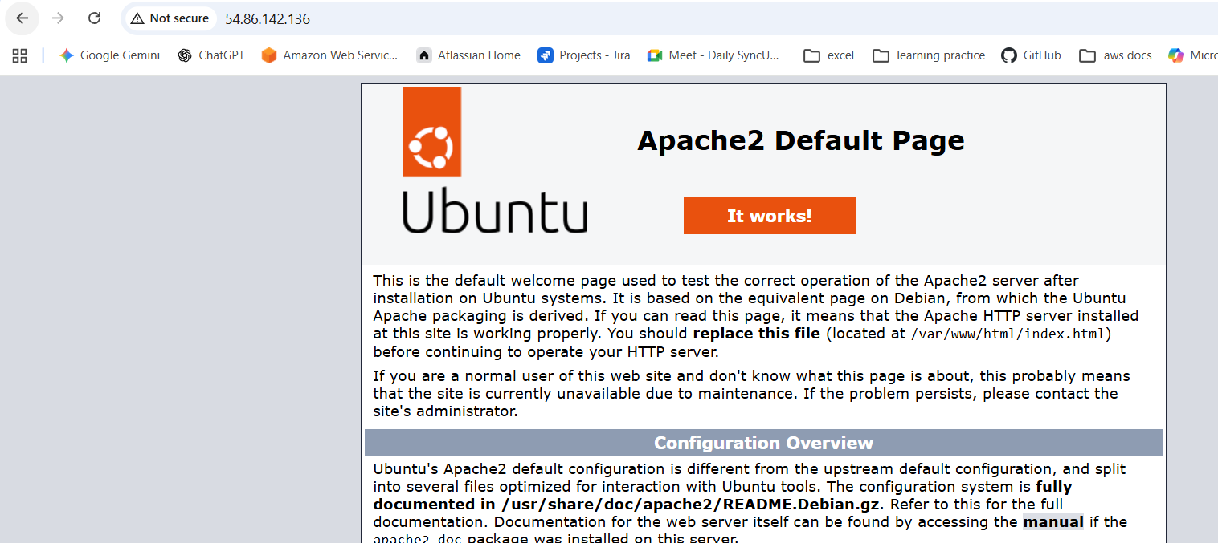

Verified on both servers
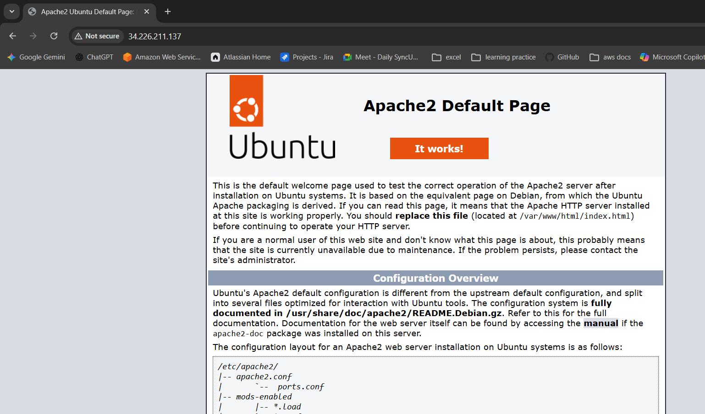
Create the user on ALL servers
ansible all -m user -a "name=weblogic state=present" --become
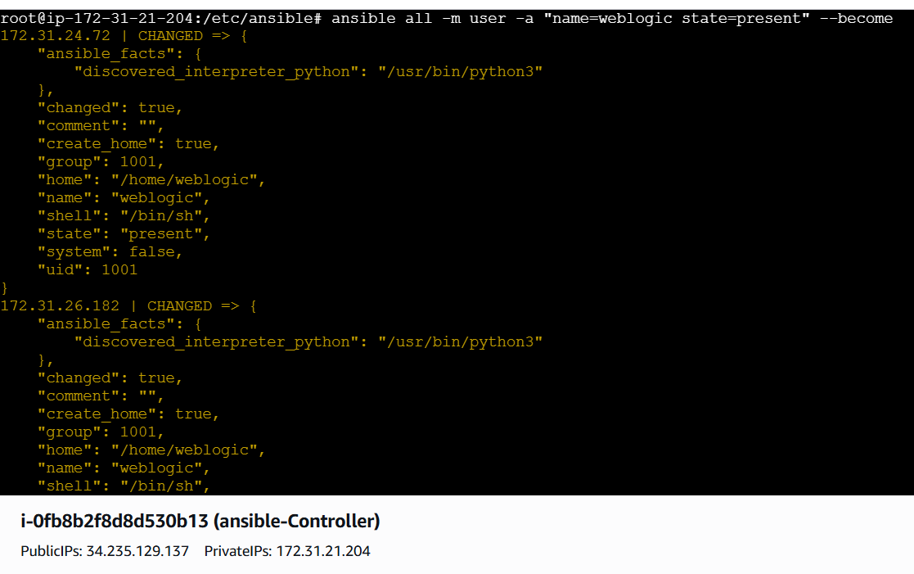

Verifying using commands
ansible all -m shell -a "id weblogic"
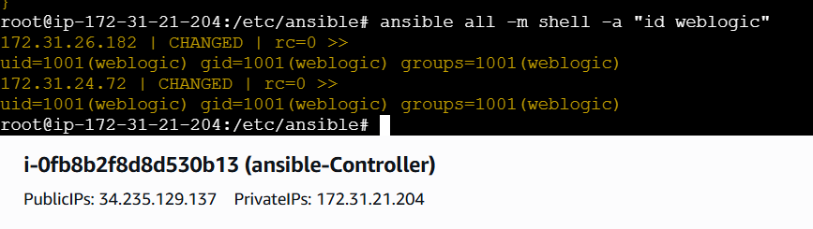

Getting permission denied while executed commands so that changed the cfg file and added the data
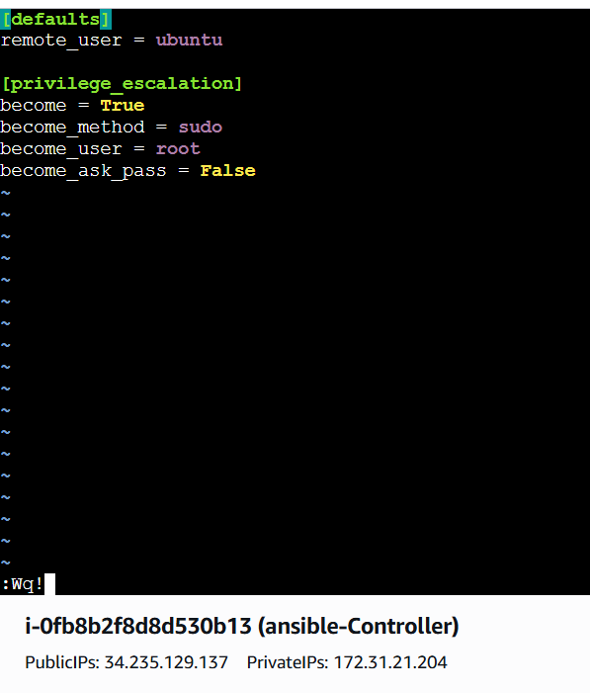
Create a file with 755 permission
ansible all -m file -a "path=/root/testfile state=touch
mode=0755"
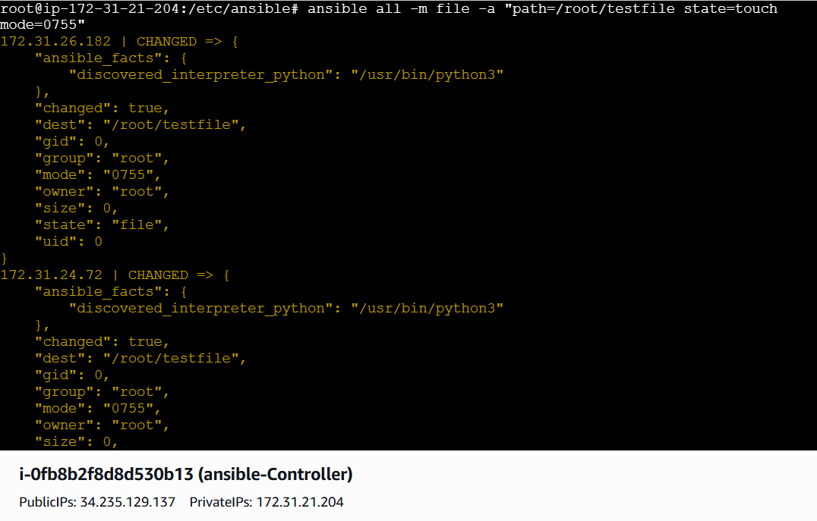
Create a Linux user group
ansible all -m group -a "name=test state=present" -b -K
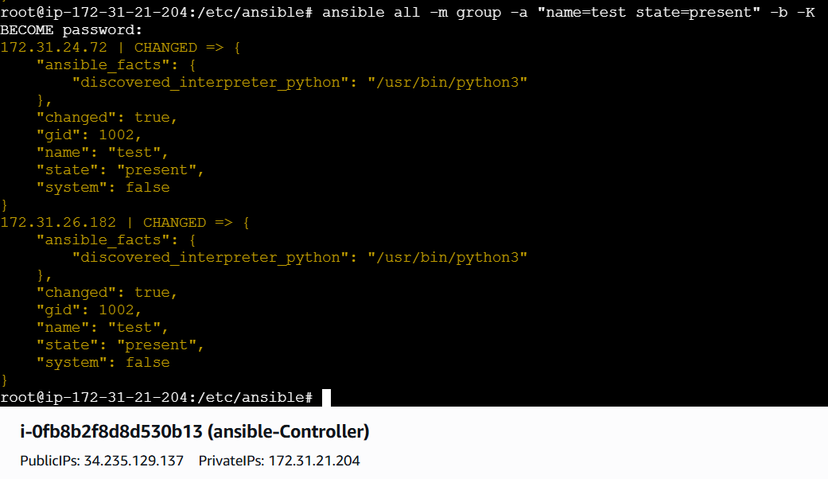

Change ownership of a file
ansible all -m file -a "path=/root/testfile group=weblogic
owner=weblogic" -b
Tips: -b is the option for become and by default it will become
root user
–K is to tell ansible to ask for SUDO password
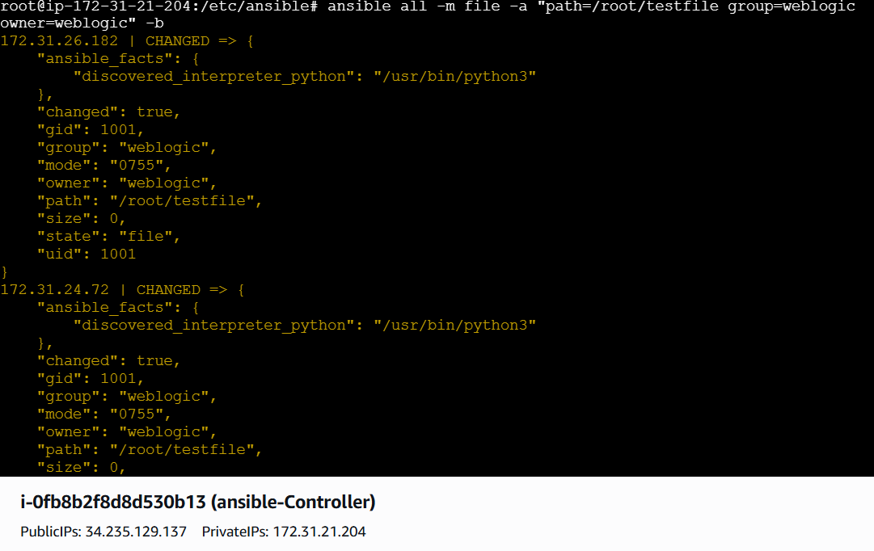

Command to delete the package
ansible all -m apt -a "name=apache2 state=absent purge=yes" --become
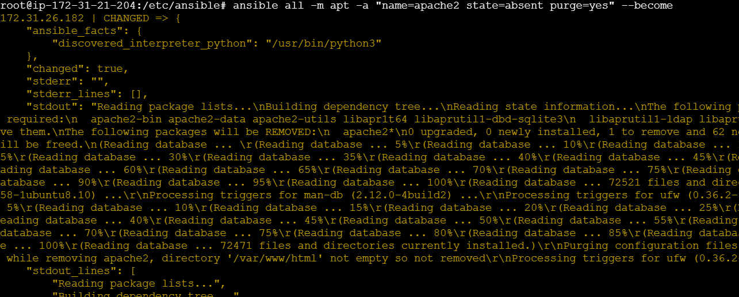

Installing nginx:
Commands: ansible all -m apt -a “name=nginx state=latest” --become
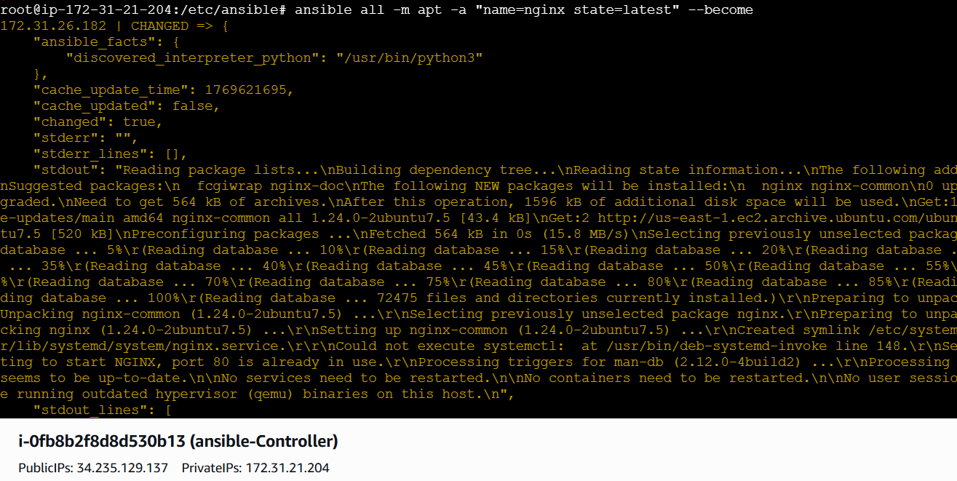
Start the service
ansible all -m service -a "name=nginx state=started" --become
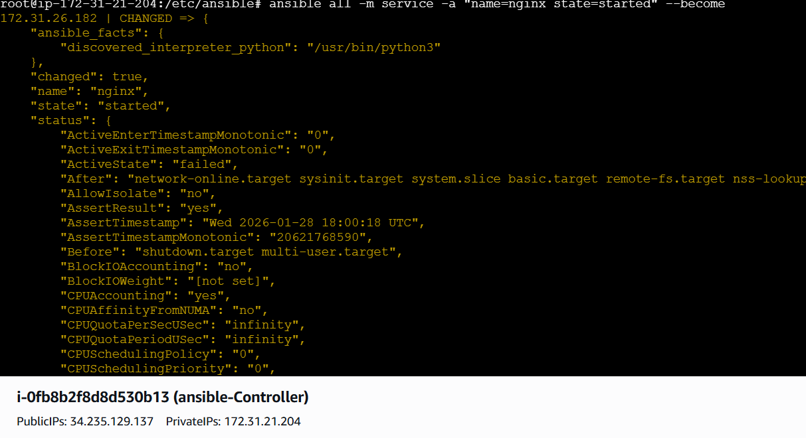

Verified in website


